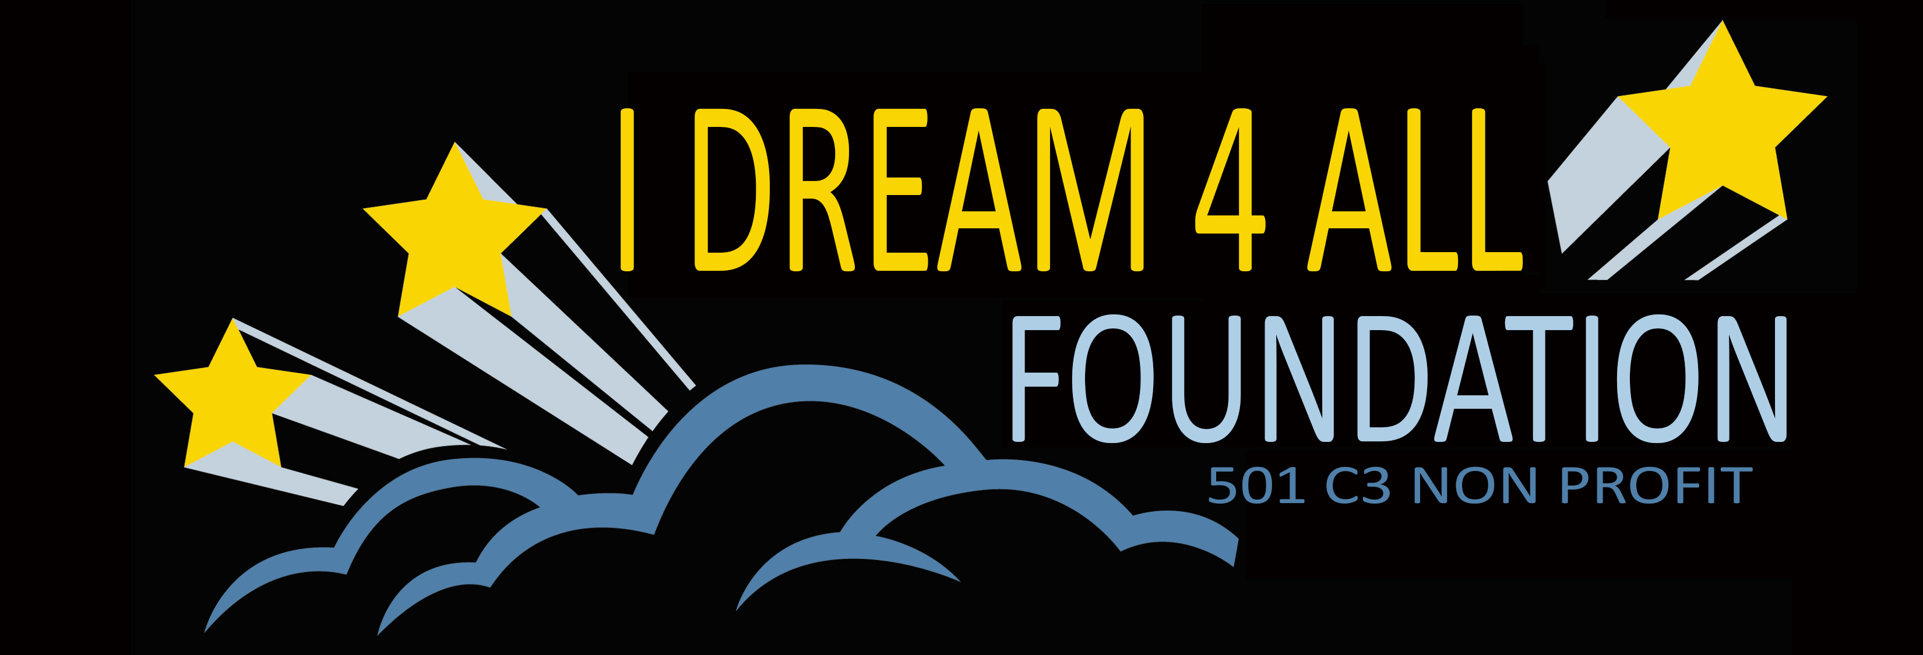

September 13, 2020

Mr. Clyde Jones
Writer/Director/Producer
Health Education Program
“The Hat Is Not Enough” Road Show

Dear Mr. Clyde Jones,

This letter confirms the formal business relationship between The I dream 4 All Foundation and your production known as, “A Hat Is Not Enough”/“The Streets Are Not The Way”, a Health Educational Program. We are delighted to adopt your project and fund it through our Foundation because it is consistent with our Foundation Charter and Mission to empower young people to make positive choices

Since we are a 501 C (3) IRS approved Charitable Foundation, we will accept donations to fund your project you and your staff will solicit for your project under the following conditions:

- Donations by checks must be made to, I Dream 4 All Foundation, Inc.
- Donations by credit or debit cards must be made on our web site
- Tax deductible receipts will be issued by our Foundation to donors

We are very excited about the project and its far reaching objective across the country and the huge positive impact this message will have in the lives of this next generation. If any Donor has any questions we will be happy to talk with them.

Kindest Regards,

Tina Weisinger- Founder
I Dream 4 All Foundation, Inc.
294 Oglesby Ave.
Calumet City, Illinois 60409
818-749-5941

